**Hyperopia**

Hyperopia, also known as farsightedness, is a common vision condition in which you can see far objects clearly, but objects nearby may be blurry. The degree of your far-sightedness influences your focusing ability. People with severe farsightedness may be able to clearly see only objects a great distance away, while those with mild farsightedness may be able to clearly see objects that are closer.

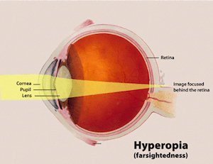

**Symptoms of Hyperopia**

* Headaches.
* Eyestrain.
* Difficulty concentrating or focusing on nearby objects.
* Fatigue or headache after performing a close task such as reading.

**Causes of Hyperopia.**

Farsightedness occurs when light entering the eye is unfocused onto the retina (the back of the eye). If the eye is too short, or the front of the eye (the cornea) is too flat, the light will not focus quickly enough to form the correct image on the retina.

**Hyperopia Diagnosis.**

Hyperopia can be diagnosed during a routine eye examination, and common forms of vision correction can be prescribed to alleviate symptoms.

**Treatment.**

When treating hyperopia, the goal is to allow your eyes to focus on objects up close. The most common way to achieve this is through spectacles for reading and working on the computer and contact lenses.